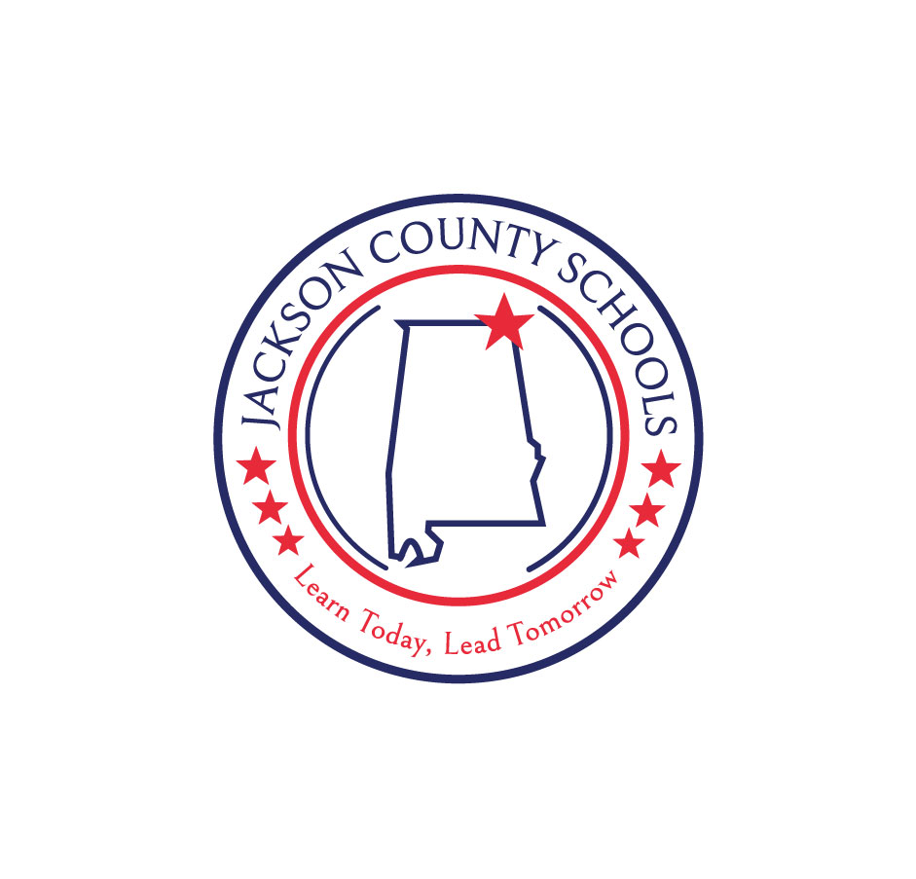

**Jackson County Schools**

**Title 1**

**Parent and Family Engagement Plan**

**2024-2025**

**Parent and Family Engagement Written Policy (Sec. 1116 (2))**

1. **Describe how the local education agency will involve parents and family members in jointly developing the LEA Consolidated Plan under section 1112, and the development of support and improvement plans for any schools identified for Comprehensive Support and Improvement (CSI), Targeted Support and Improvement (TSI), and Additional Targeted Support and Improvement (ATSI) as described in 1111(d)(1) and (2).**

The Federal Programs Advisory Committee is comprised of students, parents, teachers, administrators, and stakeholders. The purpose of this committee is to discuss how the utilization of federal funds will benefit the students of Jackson County. The committee discusses strategies, various federal programs available, and budgets allotted to fund them. All committee members are given the opportunity to voice opinions and suggestions. Each school in the Jackson County School system has a local Leadership Team responsible for designing, implementing, and evaluating Student Parent Compacts and Continuous Improvement Plan, which includes a Parent and Family Engagement component.

1. **Describe how the LEA will provide the coordination, technical assistance, and other support necessary to assist and build the capacity of all participating schools within the local education agency in planning implementing effective parent and family involvement activities to improve student academic achievement and school performance, which may include meaningful consultation with employers, business leaders, and philanthropic organizations, or individuals with expertise in effectively engaging parents and family members in education.**

The Federal Programs Parental Involvement/Consulting Teacher will conduct parent meetings and training sessions covering many topics designed to aid parents in becoming more involved in their student's education. A letter is posted in Spanish and English at the beginning of the school year informing parents/guardians about the Parent Center and materials available. A Parent Resource Center is also located at each school in a prominent area convenient to parents. Parent resources are available for check out and information provided to assist parents with various issues they may be facing. The Jackson County Schools Parent Center contains games, videos, books, and other educational resources for parents and teachers to check-out. Annual surveys conducted in conjunction with Continuous Improvement Plans will serve as a planning tool and evaluation tool in order to gain ideas and better meet the needs of parents and students. Translators are provided as needed for EL parents participating in the surveys. Jackson County Schools are continuing to utilize social media as a means of communication (Facebook JCBOEal, Twitter @JCBOEal) in order to increase family and community engagement. We continue to publish daily electronic parent engagement messages in both English and Spanish posted via social media outlets.

1. **Describe how the Local Education Agency will coordinate and integrate parent and family engagement strategies under this part with parent and family engagement strategies, to the extent feasible and appropriate, with other relevant Federal, State, and local laws and programs.**

The Jackson County School District collaborates with numerous federal, state, and locally funded programs which include, but are not limited to, the following:

*DHR – Department of Human Resources provides necessary services

*Juvenile Justice System – assists the Attendance Office with chronic truancy and non-compliance issues.

*ARC of Jackson County provides training for mentally challenged adults and supervised career placement.

*Mountain Lakes Behavioral Center provides agency counseling services for students and families. *Adult Education Programs (Northeast Alabama Community College) provides opportunities to complete high school equivalency requirements.  Various locations provide parents with convenient access.

*Impact Learning Center offers various classes and opportunities to promote literacy in Jackson County. * Career Center offers soft skill development for job placement opportunities.

*21st Century Learning offers families and communities enrichment opportunities otherwise not available in their home environment.

*Michael Scott Learning Center is a community-based organization that provides tutoring, classes in art, music and technology as well as other enrichment.

*CASA of Jackson County offers a food pantry.

*Children's Advocacy Center provides hope and healing for abused and At-Risk children.

*Local community partners provide clothing and toiletries for needy children.

*The Creative Discovery Museum Outreach Program provides lessons for parents and students which includes Science, Math, Technology, and Art.

*Numerous sites in various communities provide food, clothes, financial aid, and informational material to assist At-Risk families

**D. Describe how the local education agency will conduct, with the meaningful involvement of parents and family members, an annual evaluation of the content and effectiveness of the parent and family engagement policy in improving the academic quality of all schools served under Title I, Part A, that includes identifying barriers to greater participation by parents in activities authorized by this section (with particular attention to parents who are economically disadvantaged, are disabled, have limited English proficiency, have limited literacy, or are of any racial or ethnic minority background).**

Parents are given the opportunity through on-line and/or paper surveys to make comments and recommendations about the Parent and Family Engagement Program. Translators are provided to assist EL parents in the completion of these surveys. Additional data is gathered through the Continuous Improvement Plan where stakeholders provide feedback involving parent and family engagement. These evaluation forms are written in a uniform format, and, to the extent possible, in a language that parents can understand. The data gathered is used to establish goals and implement strategies within Continuous Improvement Plans, both at school and LEA level. All data collected will provide a basis for implementing strategies to serve students and parents more appropriately.

1. **Describe how the local education agency will conduct, with the meaningful involvement of parents and family members, an annual evaluation of the content and effectiveness of the parent and family engagement policy in improving the academic quality of all schools served under Title I, Part A, that includes identifying the needs of parents and family members to assist with the learning of their children, including engaging with school personnel and teachers.**

The Jackson County Board of Education operates The Parent Center, a free resource center, which offers educational materials and supplies to assist parents.  These materials provide additional information for parents to work with their students at home. Past surveys indicated that a small percentage of parents from Jackson County were aware of The Parent Center. Our most recent survey clearly indicates an increase in the percentage of parental involvement at each school as compared with records from previous years.

1. **Describe how the local education agency will conduct, with the meaningful involvement of parents and family members, an annual evaluation of the content and effectiveness of the parent and family engagement policy in improving the academic quality of all schools served under Title I, Part A, that includes identifying strategies to support successful school and family interactions.**

Increased meaningful communication continues to provide quality information. Data indicates the use of social media has dramatically increased parent interaction. Surveys and informal observations confirm positive and successful interactions between school and parents. Increased parental involvement during school related activities further proves these strategies are indeed successful and growth continues.

1. **Describe how the local education agency will use the findings of such evaluation described in the section above (Sec. 1116(2)(D)) to design evidence-based strategies for more effective parental involvement, and to revise, if necessary the parent and family engagement policies described in this section.**

The Federal Programs Advisory Committee, the Continuous Improvement Committees, and school Leadership Teams utilize data results to revise and update Parent and Family Engagement Plans as needed. Results of the data are addressed in each individual school's CIP Plan.

**H. Describe how the local education agency will involve parents in the activities of the schools served under this part, which may include establishing a parent advisory board comprised of a sufficient number and representative group of parents or family members served by the local educational agency to adequately represent the needs of the population served by such agency for the purposes of developing, revising, and reviewing the parent and family engagement policy.**

Parents are encouraged to serve on all committees at the local and district level.  They are invited to attend activities at school and participate in planning.  A Needs Assessment is conducted annually and sent to all parents.  Results of the data are used by the Federal Programs Advisory Committee to develop, revise, and implement the Parent and Family Engagement component.

1. **Describe how it will provide assistance to parents of children served by the school or local educational agency, as appropriate, in understanding such topics as the challenging State academic standards, State and local academic assessments, the requirements of this part, and how to monitor a child's progress and work with educators to improve the achievement of their children.**

All students receive a Student/Parent Compact which outlines state requirements involving curriculum and instruction. The compact serves as a contract dictating the responsibilities of parents, students and schools to provide the best educational opportunities possible. Home reports from state assessments are provided. Schools offer parents opportunities to discuss assessment results as requested. Grade reports are sent home every 4 1/2 weeks. Reporting periods are posted on the school and district website as well as social media. The Jackson County School District provides an on-line portal for parents to monitor their child's progress. Parent Conferences may be held as needed or requested to discuss academic and behavioral issues.

1. **Describe how it will provide materials and training to help parents to work with their children to improve their children's achievement, such as literacy training and using technology (including education about the harms of copyright piracy), as appropriate, to foster parental involvement.**

The Federal Programs Parental Involvement/Consulting Teacher provides assistance when requested. Numerous materials are available at the Jackson County Parent Center to assist parents regarding their child's educational needs. The Jackson County Board of Education provides an electronic version of the Student/Parent Handbook for each student. Hard copies are available for families without internet access. This handbook serves as a guideline for the family to understand the uses of technology in the classroom. It outlines both appropriate and inappropriate uses of technology according to the Technology Plan which is developed by a committee comprised of parents, students, staff and community members.

1. **Describe how it will educate teachers, specialized instructional support personnel, principals, and other school leaders, and other staff, with the assistance of parents, in the value and utility of contributions of parents, and in how to reach out to, communicate with, and work with parents as equal partners, implement and coordinate parent programs, and build ties between parents and the school.**

School personnel receive training, at the district and local level, dedicated to the importance of a strong parental involvement program. The LEA provides training workshops and professional development opportunities to school staff, some of which may include ways to communicate more effectively with parents, creating opportunities for parents to volunteer, or training on how to utilize various social media platforms. Also, multiple opportunities are given for parents to become equal partners in developing, establishing, and maintaining a successful working partnership with schools. Each school is required to include parents on federal and local planning committees. All programs are designed to ensure that the top priority is for all students to achieve and succeed becoming college and career ready.

1. **Describe how it will to the extent feasible and appropriate, coordinate and integrate parent involvement programs and activities with other Federal, State, and local programs, including public preschool programs, and conduct other activities, such as parent resource centers, that encourage and support parents in more fully participating in the education of their children.**

The Jackson County School District currently houses thirteen First Class Pre-K Programs at all schools except Bridgeport Middle, North Jackson High, and Stevenson Middle Schools. These programs are funded through the Office of School Readiness. Parent Engagement is strictly mandated and enforced for continual funding through OSR. Parent and Family Engagement logs are kept documenting workshops and meetings. There are private preschool programs with which the Jackson County School System works very closely to collaborate and coordinate. Also, IDEA identifies Pre-K school children with special needs and provides all available services. Each spring, the elementary schools conduct orientations and visitations for incoming Kindergarten students. A separate orientation is provided for parents of children who are entering Pre-K.

1. **Describe how it will ensure that information related to school and parent programs, meetings, and other activities is sent to the parents of participating children in a format and, to the extent practicable, in a language the parents can understand.**

A Home Language Survey which reports the language most spoken in the home, is sent to all parents upon initial enrollment. Documents disseminated to parents are translated into a language that parents can understand. Communications with parents are in an understandable and uniform format in the language most applicable to parents and translators are provided as needed. Each student is required to have a Home Language filed in their permanent record.

1. **Describe how the local education agency will ensure it provides such other reasonable support for parental involvement activities under this section as parents may request.**

The Federal Programs Parental Involvement/Consulting Teacher provides assistance when requested. Parents are welcome to visit the Parent Center or materials can be delivered to the school for parents to pick up. In addition to the Parent Center, each school houses an area for parents in a prominent area with free resources.  Materials are available in Spanish also and if requested, specific items may be ordered for resources.  Numerous materials are available at the Jackson County Parent Center to assist parents regarding their child's educational needs. Free resource websites are also available.

1. **Describe how the local education agency may involve parents in the development of training for teachers, principals, and other educators to improve the effectiveness of such training.**

Parents serve on program committees at the school and district level. Results of surveys, formal and informal interviews, and meetings are used to assist in the creation of professional development activities. The Federal Programs Advisory Committee is comprised of students, parents, staff, and stakeholders. This committee convenes semi-annually to discuss the development and implementation of the Federal Programs Consolidated and EL Plan. Parents also serve on the committees that formulate the Technology Plan, and Continuous Improvement Plans at the local and district level.

1. **Describe how the local education agency may provide necessary literacy training from funds received under this part if the local educational agency has exhausted all other reasonably available sources of funding for such training.**

Local schools agreed to relinquish their 1% set-aside for parental involvement to the Jackson County Parent Center. These monies are used to purchase materials and supplies to support education at home. Parents are encouraged to take advantage of the materials purchased for the Parent Center.  The Federal Programs Parental Involvement/Consulting Teacher also attends Open House or other school functions to explain how Title I is used to assist student achievement and to encourage parents to become more involved.

1. **Describe how the local education agency may pay reasonable and necessary expenses associated with local parental involvement activities, including transportation and child care costs, to enable parents to participate in school-related meetings and training sessions.**

All parent meetings are held in each community on a flexible schedule for the convenience of the parents in attendance.

1. **Describe how the local education agency may train parents to enhance the involvement of other parents.**

The LEA recognizes the importance of parent and family engagement at all levels. Parents are encouraged to invite other parents to participate in local parent related activities. The LEA utilizes social media to promote parent involvement. Parents can follow Jackson County Schools on both Facebook and Twitter. Both the Facebook and Twitter pages are updated multiple times each week which include daily tips for parents/ guardians.  This has been an extremely popular way to reach parents and receive positive feedback about topics presented.

1. **Describe how the local education agency may arrange school meetings at a variety of times, or conduct in-home conferences between teachers or other educators, who work directly with participating children, with parents who are unable to attend such conferences at school, in order to maximize parental involvement and participation.**

The Federal Programs Parental Involvement/Consulting Teacher conducts a minimum of two parent training sessions-one per semester. These meetings are scheduled at flexible times to be convenient for parents. One meeting is scheduled during school hours and the other after school hours. Translators are available as necessary. The Consulting Teacher is also available to assist principals/staff at any other times during the school year.

1. **Describe how the local education agency may adopt and implement model approaches to improving parental involvement.**

Professional development is provided at various state, national and local conferences, to introduce new strategies to improve parental involvement. The Jackson County School system is continually searching ways to improve parental interaction. New ideas presented are researched, discussed, and evaluated. The Family Engagement Plan is developed accordingly.

1. **Describe how the local education agency may establish a districtwide parent advisory council to provide advice on all matters related to parental involvement in programs supported under this section**

Each school annually provides the names of parents in their school to serve on the local school Leadership Team, CIP Team, and Federal Programs Advisory Committee. These committees meet as required to discuss plans and offer suggestions for revisions.

1. **Describe how the local education agency may develop appropriate roles for community-based organizations and businesses in parent involvement activities.**

Business leaders and community-based organization members partner with the LEA in providing opportunities for parental involvement. These partnerships are formed based on the needs of each community. These organizations include, but are not limited to, the following: *Local churches contribute food from pantries for weekend food programs. *Lions Club, a local civic club, provides eye glasses for needy students. *Michael Scott Learning, located in Stevenson, provides enrichment activities in schools and on site. *Alabama Science in Motion is a mobile science lab providing materials and experiences to enhance STREAM instruction. *The Impact Learning Center holds the EXPO Career Fair for 9th graders and offers CHOICES programs for 6th grade students throughout the county to help students understand the importance of responsible decision making. *The Civitan Clubs assist with the needs of the community. *The Jackson County Sheriff's Department partners with the Jackson County Board of Education to provide School Resource Officers to rotate between the schools throughout the county. There are many other community-based organizations which provide support and assistance for parental involvement activities.

1. **Describe how the local education agency will provide opportunities for the informed participation of parents and family members (including parents and family members who have limited English proficiency, parents and family members with disabilities, and parents and family members of migratory children), including providing information and school reports required under section 1111 in a format and, to the extent practicable, in a language such parents understand.**

Data is gathered though the Continuous Improvement process. Stakeholders provide feedback through surveys, conducted each Spring involving Parent and Family Engagement. The evaluation forms are written in an understand and uniform format, and to the extent possible, in a language parents can understand. This data is used to establish goals and implement strategies within the Continuous Improvement Plan, both at school and LEA level. All data collected will provide a basis for implementing strategies to serve students and parents more appropriately. Current survey results indicate a slight decrease in the percentage of Parental Involvement at each school.  In order to promote Parental Involvement, schools are participating in Family Nights through the Creative Discovery Museum and each school has a small parent resource area.  These are stocked with materials ranging from Kindergarten sight words to ACT materials for High School students.  Increased meaningful communication continues to provide quality information. Data indicates the use of social media has dramatically increased parent interaction. Surveys and informal observations confirm positive and successful interactions between school and parents. Increased parental involvement during school related activities further prove the strategies are indeed successful and growth continues.

**This LEA Parent and Family Engagement Policy has been developed jointly with, and agreed on with, parents of children participating in Title I, Part A programs as evidenced by Parents are invited and encouraged to serve on all committees. Documentation of meetings are maintained at each school. Federal Programs Advisory Committee meetings are documented by an agenda, attendance log, and minutes of the meeting. Invitation letters to the community members and announcements of the meeting are also kept on file.**